**Project Planning Phase**

**Project Planning Template (Product Backlog, Sprint Planning, Stories, Story points)**

|  |  |
| --- | --- |
| Date | 18 November 2022 |
| Team ID | PNT2022TMID07381 |
| Project Name | Project -Personal Assistance for Seniors Who Are Self-Reliant |
| Maximum Marks | 8 Marks |

# Product Backlog, Sprint Schedule, and Estimation (4 Marks)

Use the below template to create product backlog and sprint schedule

|  |  |  |  |  |  |  |
| --- | --- | --- | --- | --- | --- | --- |
| **Sprint** | **Functional**  **Requirement (Epic)** | **User Story Number** | **User Story / Task** | **Story Points** | **Priority** | **Team**  **Members** |
| Sprint-1 | Caretaker | USN-1 | As a user, I want to take Medicines on time and monitor my health | 2 | High | RITHIN GEORGE JOHNSON  SURYA KUMAR  SATHISHKUMAR   PARIVALLAL |
| Sprint-1 | Smart medicine box | USN-2 | As a user, I want to take my tablets on time by voice command | 1 | High | RITHIN GEORGE JOHNSON  SURYA KUMAR  SATHISHKUMAR   PARIVALLAL |
| Sprint-2 | Caretaker | USN-3 | As a user, my patient needs to take medicines on time and monitoring the activity | 2 | Medium | RITHIN GEORGE JOHNSON  SURYA KUMAR  SATHISHKUMAR   PARIVALLAL |
| Sprint-4 | Caretaker | USN-4 | As a user, my patient medication time and  prescription should load in database for  upcoming week | 2 | Low | RITHIN GEORGE JOHNSON  SURYA KUMAR  SATHISHKUMAR   PARIVALLAL |
| Sprint-3 | Smart medicine box | USN-5 | As a user, I need to take my medicine in nearby places with light notification | 1 | Medium | Rithin George Johnson |
| Sprint -1 | Smart medicine box | USN-6 | As a user, I need to take my medicine and I am not able see the dosage of medicine properly | 1 | High | SURYA KUMAR  SATHISHKUMAR   PARIVALLAL |
| Sprint -1 | Smart medicine box | USN-7 | As a user, Sometimes my medicine aren’t in stock and I usually forget the Stock of my medication. | 2 | Medium | RITHIN GEORGE JOHNSON  SURYA KUMAR  SATHISHKUMAR |
|  |  |  |  |  |  |  |

# Project Tracker, Velocity & Burndown Chart: (4 Marks)

|  |  |  |  |  |  |  |
| --- | --- | --- | --- | --- | --- | --- |
| **Sprint** | **Total Story Points** | **Duration** | **Sprint Start Date** | **Sprint End Date (Planned)** | **Story Points**  **Completed (as on**  **Planned End Date)** | **Sprint Release Date (Actual)** |
| Sprint-1 | 20 | 6 Days | 24 Oct 2022 | 29 Oct 2022 | 20 | 29 Oct 2022 |
| Sprint-2 | 20 | 6 Days | 31 Oct 2022 | 05 Nov 2022 | 20 | 05 Nov 2022 |
| Sprint-3 | 20 | 6 Days | 07 Nov 2022 | 12 Nov 2022 | 20 | 12 Nov 2022 |
| Sprint-4 | 20 | 6 Days | 14 Nov 2022 | 19 Nov 2022 | 20 | 19 Nov 2022 |
|  |  |  |  |  |  |  |
|  |  |  |  |  |  |  |
|  |  |  |  |  |  |  |
|  |  |  |  |  |  |  |

**Velocity:**

Imagine we have a 10-day sprint duration, and the velocity of the team is 20 (points per sprint). Let’s calculate the team’s average velocity (AV) per iteration unit (story points per day)

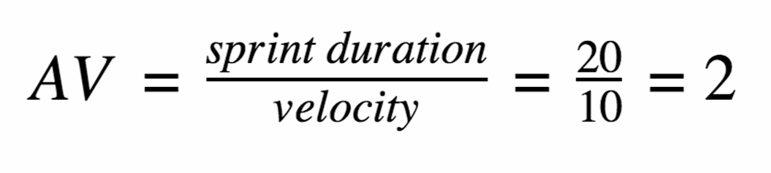

**Burndown Chart:**

A burn down chart is a graphical representation of work left to do versus time. It is often used in agile [software development](https://www.visual-paradigm.com/scrum/what-is-agile-software-development/) methodologies such as [Scrum.](https://www.visual-paradigm.com/scrum/scrum-in-3-minutes/) However, burn down charts can be applied to any project containing measurable progress over time.